S. s. SUMIDA
Biology 340
Comparative Embryology

Laboratory Exercise 4
Laboratory Examination of the Pig Embryo

Introduction

With the use of serial cross-sections of chicken embryos, you recently completed one of the classic exercises in the history of animal biology – the study of the chicken embryo. With that background you will now turn to another amniote, a placental mammal, the pig.

This study will be made significantly easier by your experience with the chicken embryo. I fact, you may be surprised at how similar they appear. Fortunately, pig embryos experience less of the ventral flexion and much less of the torsion you saw in the chicken embryo.

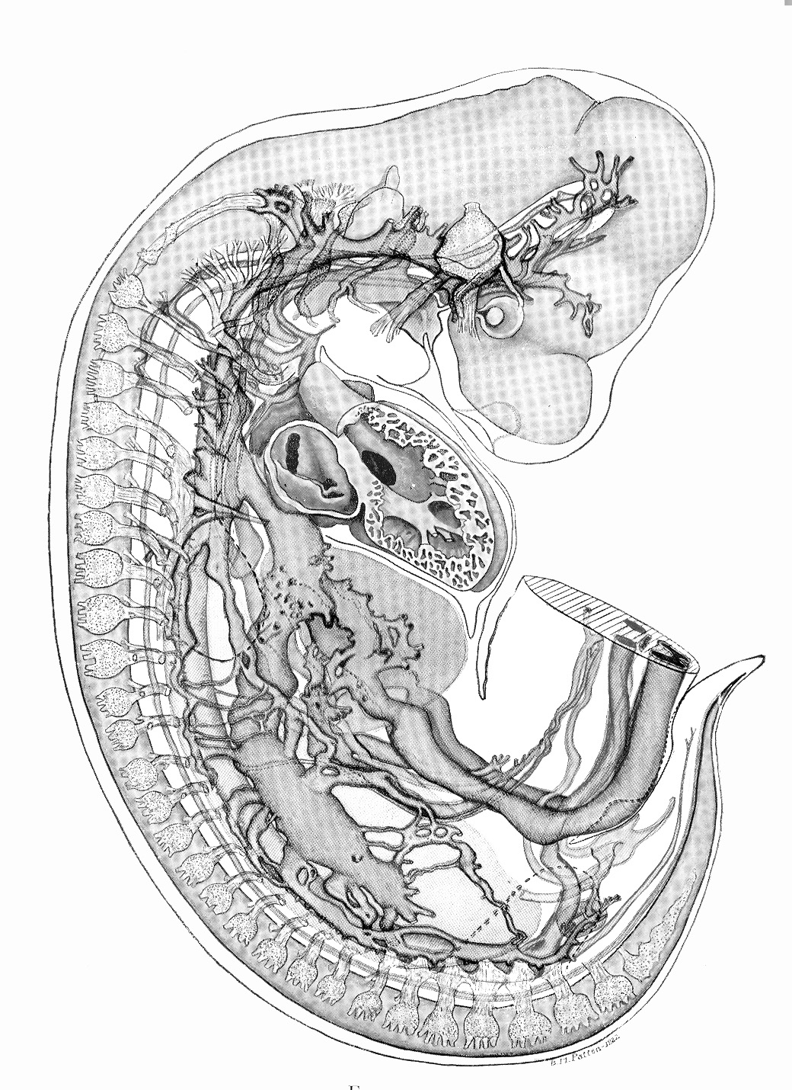

Figure 1. Reconstruction of the organ systems of a pig embryo, between nine and ten mm in size. After Patton (1948).

Materials

Because of your extensive examination of 24, 33, 48, and 72 hour chicken embryos, you will not go through as many stages with the pig. Nonetheless (as always), please be sure that you DO NOT mix slides back and forth between different slide sets! We will not be examining whole mounts, but be sure to consult Figures 1 and 2 of this protocol, as well as Figure 5.1 in your lab manual. We will be examining 8 and 15 mm pig embryos. The 8 mm embryos will be most similar to the 10 mm embryos of your laboratory manuals. The 15 mm embryos will be more advanced in their development, but because of that will demonstrate some exciting structures.

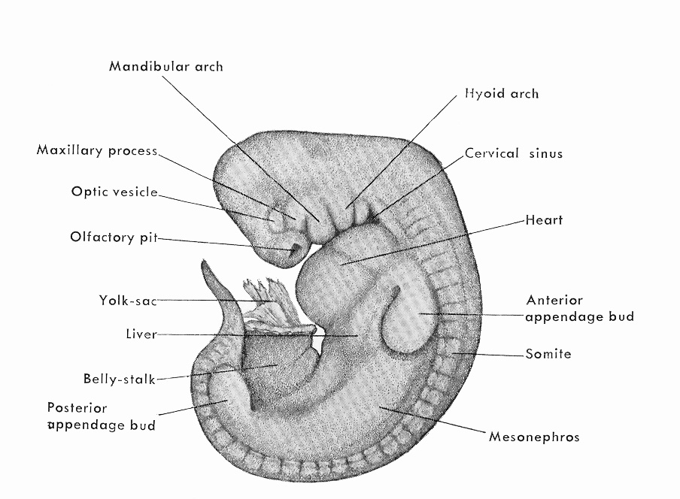

Figure 2. Diagrammatic illustration of an 8 mm pig embryo. Age approximately, 18-19 days. After Minot (1911) and Patton (1948).

8 mm Pig Embryo – Overview

The first set of serial sections you will examine will be the 8mm pig embryo. Up through the 10 mm size, pig embryos are sufficiently similar to the structures you have seen in amphibians and birds that your experience will allow you to orient with reasonable confidence. Each set for an 8 mm embryo is usually on five to six slides.

Even though the pig embryo is not developing within the constraints of an egg shell, the maternal uterine environment is not completely unrestricted. That combined with the typically precocious development of the brain and head does indeed result in a moderate to significant amount of ventral flexion. However, there is not the torsion you observed in chicken embryos. There are a series of regions in which the ventral curvature is most pronounced: the cranial flexure, the cervical flexure, and dorsal flexure, and the lumbo-sacral flexure.

In the region of the head, the thin skin allows reasonable observation of the brain. Using Figures 12.9 and 12.10 from your laboratory manual, note that the forebrain or prosencephalon is subdivisible into a telencephalon and diencephalon. A nasal pit should be fairly easy to find. The midbrain or mesencephalon is not subdivided. Depending on the maturity of your individual, the hind brain or rhombencephalon may or may not demonstrate subdivision into a metencephalon and myelencephalon. At this stage, the mandibular arch is
clearly developed, and usually three more pouches will be present. Recall from your lectures that gill pouches (with clefts between successive pouches) are served by dorsal root cranial nerves. In an 8 mm embryo, most of the twelve pairs of cranial nerves will be developed, although I (olfactory) and II (optic) probably will not.

Along the trunk, somites will be well developed and paddle-shaped limbs buds are well along in development for both the fore- and hindlimbs. The derivatives of the digestive and respiratory (ventilator) systems will be more developed than what you saw in your chicken embryos. You will note the coelomic space surrounding structures of the digestive system. One system that will show remarkably greater development in the pig relative to what you saw in the chicken is the excretory system. Just behind the head, the heart will also be impressive in its size and development.

Exercise 1. Major Structures of the 8mm Pig Embryo.

Exercise 1A. Nervous System and Cranial Nerves.

Recall that in early development the brain is subdivisible into a fore-, mid-, and hindbrain. The forebrain, or prosencephalon gives rise to the telencephalon and diencephalon. At the 8 mm stage they are not always distinguishable. As serial sections hit the apex of the developing embryo first, the initial parts of the brain to be seen are often part of the hindbrain, either the metencephalon or myelencephalon. The myelencephalon may be distinguished by its relatively thicker epithelial walls, whereas the epithelial walls of the metencephalon has a fairly thin “roof plate”.

Due to the curvature of the head, structures of the forebrain will (usually) be seen later in the serial section series than those of the hindbrain. The diencephalon is the more caudal part of the forebrain or prosencephalon. The most conspicuous features of this region are paired lateral outgrowths which will form the optic vesicles. A more ventrally directed outgrowth in this region is the infundibulum. It will grow ventrally to contact the dorsally directed Rathke’s pouch.

The midbrain or mesencephalon is difficult to distinguish in and of itself at the 8 mm stage. However, the best way to attempt to recognize it as you page through sections is that the neural tube will appear to constrict in this region.

You have already reviewed the significance of dorsal root cranial nerves, versus ventral root cranial nerves, versus special sense nerves in both the lecture and laboratory. At the 8 mm stage, the special sense nerves I (olfactory) and II (Optic) are rarely developed well enough to recognize. However, if you find the developing nasal pits (Figure 12.15P-Q of your laboratory manual) you may sometimes find it. It is not difficult to locate the optic vesicles; then you can sometimes detect II (Figure 12.15J-N of your laboratory manual) connecting to or toward them, however they usually aren’t detectable at this stage.

Of the dorsal root cranial nerves, most can be seen at the 8 mm stage. Table 1 below and Figure 6.2 of your laboratory manual provide keys to the ganglia that are associated with each of the cranial nerves.

Table 1. Major Dorsal Root Cranial Nerves and associated ganglia visible in 8 mm pig embryos. Figure references are from the laboratory atlas/manual.

Cranial Nerve | Associated Ganglion
Trigeminal; Mandibular Branch (V₃)  (Figure 12.15K-M) | Semilunar Ganglion  (Figure 12.15E-G)
Facial Nerve (VII)  (Figure 12.15H-J) | Geniculate Ganglion  (Figure 12.15E-F)
Vestibulocochlear (VIII) | Acoustic Ganglion  (Figure 12.15E)
Glossopharyngeal (IX)  (Figure 12.15E) | Superior Ganglion & Petrosal Ganglion  (Figure 12.15G-H)
Vagus (X)  (Figure 12.15E) | Jugular Ganglion & Nodose Ganglion  (Figure 12.15I-J)

What you will be able to see of the trigeminal nerve (V) will be dominated by its third branch, the mandibular branch of the trigeminal nerve (V₃). Branching off from its associated semilunar ganglion will be the ophthalmic nerve (V₁) and the maxillary nerve (V₂). Figure 12.15K-M show good examples of this set of nerves, but be sure to page back and forth to see as much of the extent of the trigeminal as possible.

Figure 12.15G-H will give you good view of the facial nerve (VII) and the vestibulocochlear nerve (VIII). The first structure you are likely to see in this part of your search is the large geniculate ganglion associated with the facial nerve. The acoustic ganglion will help to give away the position of the vestibulocochlear. (Remember, that evolutionarily, VIII is a branch of VII.)

Slightly higher up in the sequence, you may have better luck in seeing the glossopharyngeal nerve (IX) and its associated superior and/or petrosal ganglia. Figure 12.15G-H shows this cranial nerve. One of the most extensive of the dorsal root cranial nerves is, of course, the vagus nerve (X). Along with its jugular ganglion, the vagus appears more caudally (see Figure 12.15D,I,J). Even farther caudally, an evolutionary branch of X, XI, the spinal accessory nerve may be visible (Figure 12.15D).

Turning to the ventral root cranial nerves, in the region near the metencephalon (Figure 12.15D), attempt to find the right and/or left oculomotor (III) nerves emerging. Ultimately, III will innervate all of the extrinsic ocular muscles except for two. It will also innervate the eyelid lifting muscle, the levator palpebrae superioris muscle. Nearby, the trochlear nerve (IV) usually is not visible at this stage. Likewise, the abducens nerve (VI) is difficult to find at this stage. The hypoglossal nerve (XII) should be easier to find in the 8 mm stage. If visible, try to find it as a series of rootlets merging together to make a larger nerve (Figure 12.15E).

Through the rest of the 8 mm embryo, features of the dorsal hollow nerve cord should be easy to distinguish. The cord itself will be seen to give rise to segmental spinal nerves. The position of origin of the neural crest cells may by this point have coalesced to form dorsal root ganglia of spinal nerves (e.g. Figure 12.15H-P). As you pass the limb buds, try to see the complex connections between nerves as they contribute to the brachial plexus (e.g. Figure 12.15Y) for the forelimb and the lumbosacral plexus for the hindlimb.

Exercise 1B. Digestive and Respiratory Systems.

Note, the respiratory system – that which ventilates the lungs is actually an embryologically derived component of the digestive section.

In going through the cranial nerves, you have already passed carefully through the oral cavity. If you haven’t already, find Rathke’s Pouch and the infundibulum in association with one another. In the region of the pharynx, the gut tube is considerably flattened. From it you will see a series of four pairs (usually, could be more) of pharyngeal pouches emerging from the pharynx. In almost all cases in mammals, the pouches don’t break all the way through to form complete gill slits.

In the floor of the pharynx at the level of the most posterior pair of pharyngeal pouches, a median ventral groove appears. As you page through sections caudal-ward (Figure 12.15W-X), the groove becomes a tube. The tube will bifurcate (split) to form the lung buds.

Caudal to the pharynx, the split between the trachea and esophagus marks the divergence of the respiratory system from its origin in the digestive system (Figure 12.15T-U). Using Figure 12.15Z, note the marked dilation of the gut tube that indicates you’re in the stomach. Immediately caudal to the stomach, (and still part of the embryonic foregut), the primordial of the liver + gall bladder, and the pancreas can be seen in a manner similar to that shown in Figure 12.15CC. At this stage, the pancreas will still be two separate entities, the dorsal lobe of the pancreas, and the ventral lobe of the pancreas. Page carefully and slowly caudally, and you ought to catch the section in which the ducts from the liver (hepatic duct) or pancreas (pancreatic duct) enter into the gut tube (here, the duodenum).

Depending on the maturity of the individual you have sectioned, you may or may not see intestines that have begun to coil up. This will be easier to see in the 15 mm embryo.

The dilated caudal end of the gut tube is where the allantoic stalk enters the cloaca.

Exercise 1C. The Coelom.

When first organized, the coelomic space consisted of paired, right and left sides. With closure (“zipping up”) of the embryonic body ventrally, the right and left sides are carried toward one another and the gut tube is enclosed within the visceral peritoneum and suspended from the dorsal mesentery. A ventral mesentery is present only in the region of the foregut, but even there it is not entirely simple. The liver and pancreas form in ventral mesentery, and thus subdivisions of it suspend them (e.g. Figure 12.15CC). By this stage, the intra-embryonic coelom is continuous with the extra-embryonic coelom at only a very restricted area – near the “belly stalk”. Photos 6.35-36 comes as close as any to illustrating this, but you should page forward and back to try to find the connection.

Separate pericardial and pleural subdivisions of the coelom generally are not yet distinct at this stage. However, by this stage, a partition between the future abdominal cavity and heart+lung cavity (pericardial + pleural cavities) has begun to form. Although incomplete at this stage, the transverse septum (e.g. Figure 12.15W) will be in the initial stages of formation.

Exercise 1D. The Excretory System.

The excretory system is derived from the segmental intermediate mesoderm. Segmental components from the entire length of the body have expression at some point in development. From cranial to caudal, the whole of the presumptive kidney may be subdivided in the cranialmost (transitory) pronephros, the middle (also transitory) mesonephros, and the precursor of the adult kidney, the caudalmost metanephros. In an 8 mm pig embryo, it is unlikely that you will see much of the pronephros remaining. Only some of the tubules will persist at this stage. If you do see them, they are already in the process of being appropriated by the mesonephric duct.

On the other hand, the development of the mesonephric kidney is much greater than anything you have seen previously. The mesonephric kidney is large and easily visible in its retroperitoneal position. Figures 12.15Y-Z show it dramatically. The more caudal metanephric kidney is not well developed yet, but may be visible as a slender metanephric diverticulum near the level of the pelvic limb.

Exercise 1E. Structures of the Circulatory System.

The functioning components of the circulatory system are already well into their development before the 8 mm stage in the pig. The heart is already established as a medial tubular organ receiving blood caudally from the common cardinal veins (also known as sinuses) and pumping it cranially toward the aortic arches via the ventral aorta. The aortic arches bring blood dorsally up past the gill pouches (just as in the gills slits of a fish) before passing caudally as the paired dorsal aortae. Eventually, the paired dorsal aortae will fuse or degenerate depending on the region considered.

With the possible exception of the massive developing kidney, the heart may be the most visible of organs in the 8 mm embryo. It is easily visible in Figure 12.15R-Y of your lab manual. Be sure to find similar views in your examination organism. The heart’s rapid growth at this stage is causing a bending of the tubular structure such that the (as yet undivided) ventricle is pushed slightly to the left. The atrium remains anchored cranially by its attachment to the ventral aorta and aortic arches. By the 8 mm stage, the atrium is often beginning its subdivision into right and left sides. Attempt to find both.

In general, six pairs of aortic arches develop in vertebrates. They extend around the pharynx from the ventral to dorsal aorta. In an 8 mm embryo, the cranialmost of these are already degenerating (if they haven’t already done so). The second set may also be on the way out. In mammals the fifth degenerates (see your lecture notes), so you could see aortic arches II, IV, and VI. Figure 12.15 N-O shows parts of these blood vessels embedded in the tissue between gill pouches. With the aid of your lecture notes, be sure you understand their orientation. The third aortic arch will give rise to parts of the carotid arteries. The fourth to the arch of the aorta; and the sixth to the pulmonary service to the lungs. (See also Figures 9.18 and 9.17D of your laboratory manual.)

More caudally, the dorsal aorta will give rise to paired segmental arteries for each segment. In the abdominal region, one major unpaired vessel serves the foregut, midgut, and hind gut respectively. They are the celiac artery, anterior mesenteric artery (+ superior mesenteric artery) and posterior mesenteric artery (= inferior mesenteric artery) respectively. The superior mesenteric artery (e.g. Figure 12.15HH,II,JJ) is usually the easiest to locate. You can sometimes find the celiac artery by passing forward from your identification of the superior mesenteric.

In addition to arterial supply, the head region and body must be drained as well. The anterior cardinal veins (Figure 12.15H-O) drain the head and upper thoracic region, whereas the posterior cardinal veins (also known as the “subcardinal veins” in your laboratory manual, F Figure 12.15 FF-JJ) drain more caudal regions of the embryo. The cardinal veins in the head region will be placed lateral to the paired dorsal aortae. They are generally somewhat more thinly walled as well. See Photos 6.19-6.21 for examples. The posterior cardinals are most easily located just lateral to the developing mesonephros. See Photo 6.25 as an example to orient, then follow them cranially and caudally.

Exercise 1F. Limb Buds.

Although the internal components of the forelimb and hindlimb are not yet developed at the 8 mm stage, the limb buds are clearly evident. Figure 12.15V-Z demonstrate this nicely. The nerves of the brachial plexus can be seen entering the forelimb. However, the nerves of the lumbosacral plexus might not be easily viewed at this stage.

Exercise 2. Major Structures of the 15mm Pig Embryo.

Now, turn to the 15 mm pig embryo. Sectioned individuals can take up as many as 18 to 20 slides. The directions to find structures in this stage embryo are essentially similar to those for the 8 mm embryo. However, also attempt to find the following structures which were difficult or impossible to find in the 8 mm embryo:
- Olfactory Nerve (I)
- Optic Nerve (II)
- Trochlear Nerve (IV)
- Abducens Nerve (VI)
- Hypoglossal Nerve (XII)
- Coiling of intestines
- Lumbosacral plexus

References

Minot, C. S. 1911. A Laboratory Textbook of Embryology, Second Edition. The Blackiston Company, Philadelphia, Pennsylvania. 402 pages.

Patton, B. M. 1948. Embryology of the Pig, Third Edition. McGraw-Hill Book Company, New York, New York. 352 pages.

